WORKSHEET “Unit 0 Hello”

My name is ___________________________________________ 2nd Grade_______

(Name) (Surname)

**I) Trace and match.**

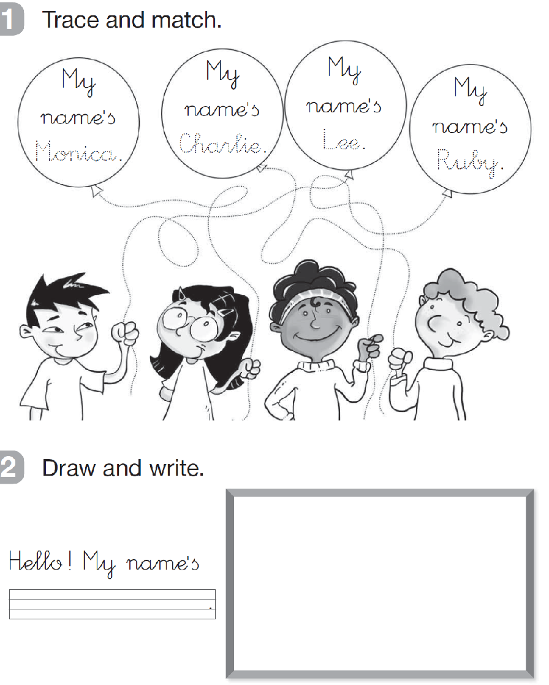

**II) Write your name and draw yourself.**



**III) Read and colour.**

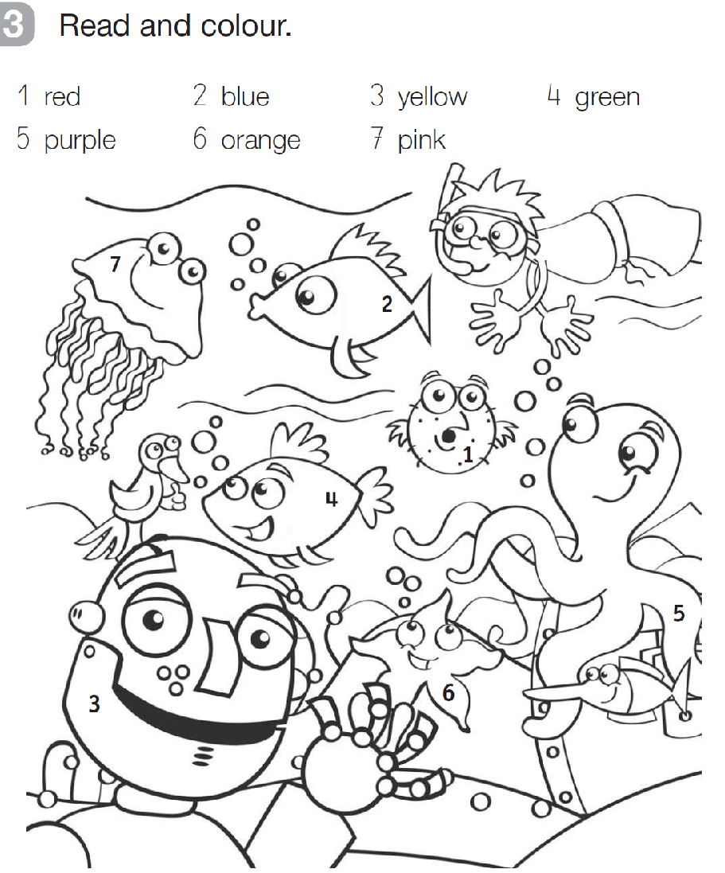

**IV) Trace the numbers**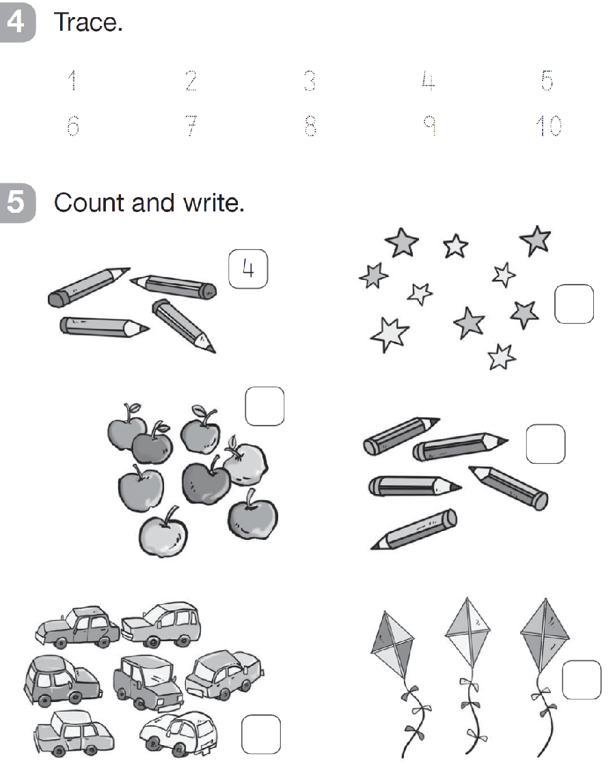

**V) Count and write the number in the box.**